ABSTRACT

The world of banking has assumed a new dimension at dawn of the 21st century with the advent of tech banking, thereby lending the industry a stamp of universality. In general, banking may be classified as retail and corporate banking. Retail banking, which is designed to meet the requirement of individual customers and encourage their savings, includes payment of utility bills, consumer loans, credit cards, checking account and the like. Corporate banking, on the other hand, caters to the need of corporate customers like bills discounting, opening letters of credit, managing cash, etc. Metamorphic changes took place in the Indian financial system during the eighties and nineties consequent upon deregulation and liberalization of economic policies of the government. India began shaping up its economy and earmarked ambitious plan for economic growth. Consequently, a sea change in money and capital markets took place. Application of marketing concept in the banking sector was introduced to enhance the customer satisfaction the policy of privatization of banking services aims at encouraging the competition in banking sector and introduction of financial services. Consequently, services such as Demat, Internet banking, Portfolio Management, Venture capital, etc, came into existence to cater to the needs of public. An important agenda for every banker today is greater operational efficiency and customer satisfaction.

INDEX
TITLE
ABSTRACT
Pageno
1. Title of the project 1
1.1 Introduction 1
1.2 Objectives of Research 1
1.3 Problem statement 2
2. Review of Literature 2
3. Data Collection 3
4. Methodology 3
4.1 Exploratory Data Analysis 4
4.1.1Figures and Tables 4
4.2 Statistical techniques and data visualization 6
4.3 Data Modeling Using Supervised ML techniques 7
5. Finding and Suggestions 8
6. References 10
7. Conclusion 10

Bank Marketing
1.1 Introduction
Python is a popular programming language. It was created by Guido van Rossum, and released in 1991.It is used for:
- web development (server-side),
- software development,
- mathematics,
- System scripting.
- Python runs on an interpreter system, meaning that code can be executed as soon as it is written. This means that prototyping can be very quick.
Artificial Intelligence is an approach to make a computer, a robot, or a product to think how smart human think. AI is a study of how human brain think, learn, decide and work, when it tries to solve problems. And finally this study outputs intelligent software systems.The aim of AI is to improve computer functions which are related to human knowledge, for example, reasoning, learning, and problem-solving.It is composed of
- Reasoning
- Learning
- Problem Solving
- Perception
- Linguistic Intelligence
1.2 Objectives of Research
- Identify the consumer response to the company’s product.
- Know the consumers’ needs and expectations.
- Seek maximum information about the consumer, i.e. the know consumers’ income range, their location, buying behavior, etc.
- Know the nature and extent of competition and also the strength and weaknesses of the competitors.
- Check the reaction of the dealers to the company policies.
- Evaluate the reputation of the company in the market.
- Identify and solve the marketing problems of the company.
- Search for new marketing opportunities.
- Find out alternative uses of the existing products.
- Estimate the cost of marketing of goods and service.

1.3 Problem Statement
Banks increasingly compete outside of their home countries, and operating environments often differ sharply across countries, both in terms of financial markets and credit risk..
Marketing of bank products is the aggregate function absorbed at providing facility to satisfy customer’s monetary needs and wants, more than the rivalry keeping in view the organizational objectives. Banking is a personalized service oriented industry and hence should provide services which satisfy the customers’ needs. . The main role of the bank is not only to attain and win more and more customers but also to preserve them through operative customer facility. Marketing as associated to banking is to explain a suitable promise to a customer through a variety of products and services and also to confirm operative distribution through satisfaction.
2. Review of Literature
A number of studies have been conducted both in India and abroad over a period of time regarding the marketing strategies applicable in the banking sector. Followings few of the studies are reviewed hereunder as they would facilitate a clear backing for carrying out the present study.
Talwar, R.K. (1975), Chairman of „Working Group on Customer Service in Banks‟ noted that there was considerable ignorance about the facilities and services offered by banks and the roles they were required to play. Most bank customers are unaware of various schemes and services offered by banks. The group recommended educational campaigns to be carried out by banks illustratively and every customer of bank should be provided a booklet containing the range of services offered by banks. The survey conducted by the working group pointed out that by and large less educated people and females are far away from the banks. The study observed that developing banking habits is not only a strategy for social uplift only but is equally important a strategy for bank marketing in the long run.
3. Data Collection
We have collected information about appropriate variables, scale & facts regarding our study. Some information was collected from internet, official website. the dataset that is collected is bank-additional-full.csv. The independent variables are age, job, education, duration, previous, emp.var.rate, cons.price.idx, cons.conf.idx, euribor3m, nr.employed. y is the dependent variable it shows that the customer subscribed to that particular bank or not

4. Methodology
On doing the literature survey of various methods for fraud detection we come to the conclusion that to detect credit card fraud there are multiple approaches like
· Logistic Regression
· Decision Tree
· Random Forest
· Support Vector Machine
· KNN
Logistic regression:
Two advanced data mining approaches, support vector machines and random forests, together with the well known logistic regression as part of an attempt to . The study is based on real-life data of transactions from an international credit card operation. It is well understood, easy to use, and remains one of the most commonly used for data-mining in practice. It thus provides a useful baseline for comparing performance of newer methods. Supervised learning methods for fraud detection face two challenges.
Decision Tree:
Decision trees are statistical data mining technique that express independent attributes and a dependent attributes logically AND in a tree shaped structure. Classification rules, extracted from decision trees, are IF-THEN expressions and all the tests have to succeed if each rule is to be generated .Decision tree usually separates the complex problem into many simple ones and resolves the sub problems through repeatedly using. Decision trees are predictive decision support tools that create mapping from observations to possible consequences. There are number of popular classifiers construct decision trees to generate class models. The work demonstrates the advantages of applying the data mining techniques including decision trees and SVMs to the credit card fraud detection problem for the purpose of reducing the bank’s risk. The results show that the proposed classifiers of C&RT and other decision tree approaches outperform SVM approaches in solving the problem under investigation.
Random Forest:
The popularity of decision tree models in data mining arises from their ease of use, flexibility in terms of handling various data attribute types, and interpretability. Single tree models, however, can be unstable and overly sensitive to specific training data. Ensemble methods seek to address this problem by developing a set of models and aggregating their predictions in determining the class label for a data point. A random forest model is an ensemble of classification (or regression) trees.
Ensembles perform well when individual members are dissimilar, and random forests obtain variation among individual trees using two sources for randomness: first, each tree is built on separate bootstrapped samples of the training data; secondly, only a randomly selected subset of data attributes is considered at each node in building the individual trees. Random forests thus combine the concepts of bagging, where individual models in an ensemble are developed through sampling with replacement from the training data, and the random subspace method, where each tree in an ensemble is built from a random subset of attributes.
Support Vector Machine:
The basic idea of SVM classification algorithm is to construct a hyper plane as the decision plane which making the distance between the positive and negative mode maximum .The strength of SVMs comes from two important properties they possess - kernel representation and margin optimization. Kernels, such as radial basis function (RBF) kernel, can be used to learn complex regions. A kernel function represents the dot product of projections of two data points in a high dimensional feature space.
KNN:
KNN can be used for both classification and regression predictive problems. However, it is more widely used in classification problems in the industry. To evaluate any technique we generally look at 3 important aspects:
1. Ease to interpret output
2. Calculation time
3. Predictive Power
4.1 Exploratory Data Analysis
4.1.1 Figures and Tables
Original dataset for bank marketing

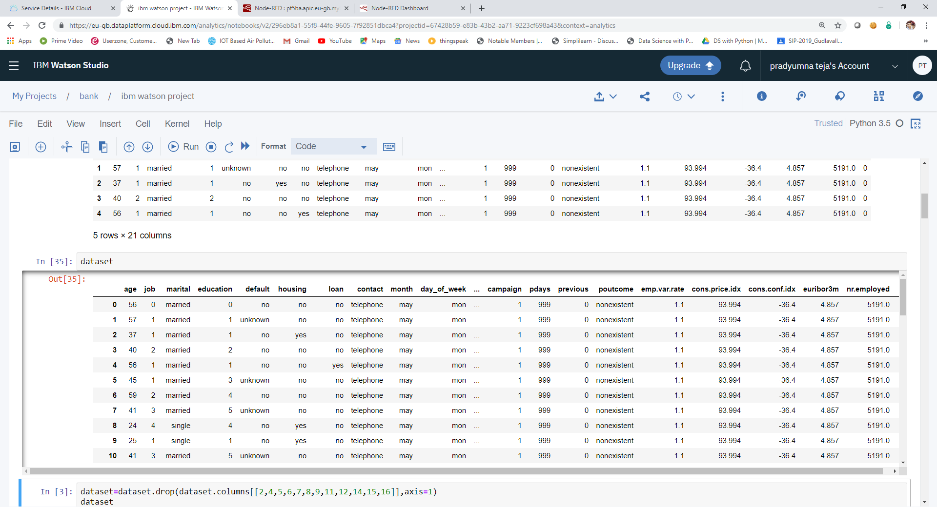
After dropping some unwanted values

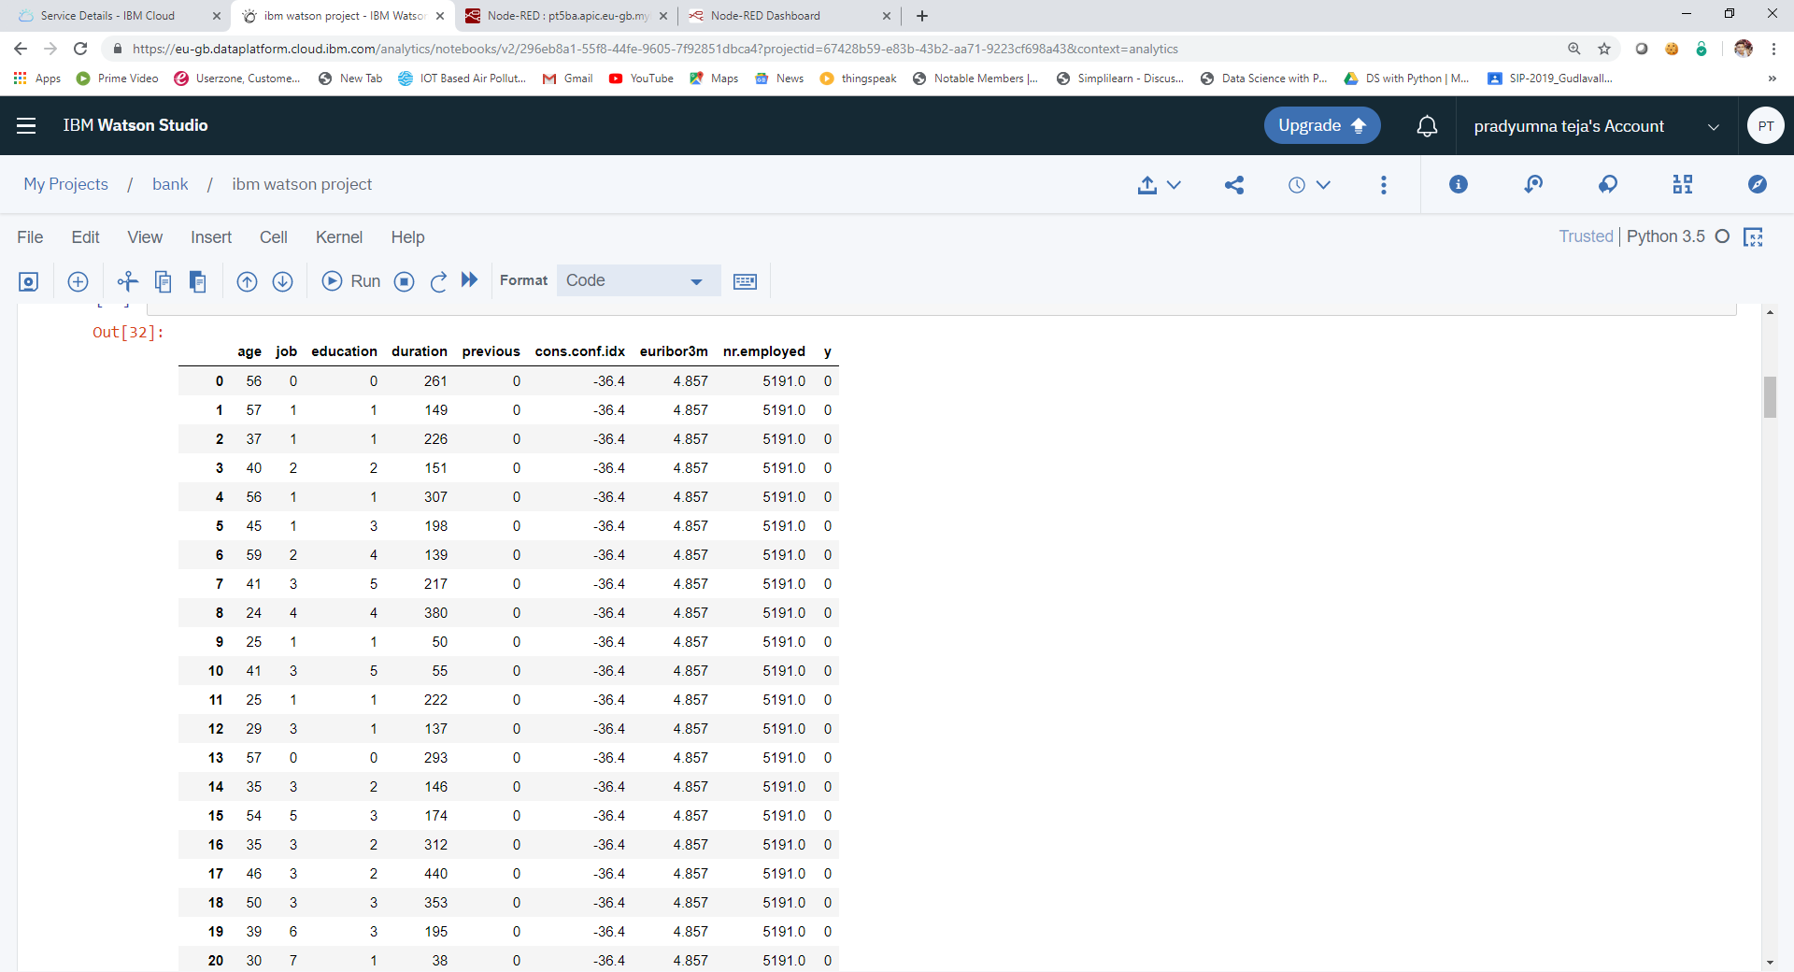

Correlation between independent variables

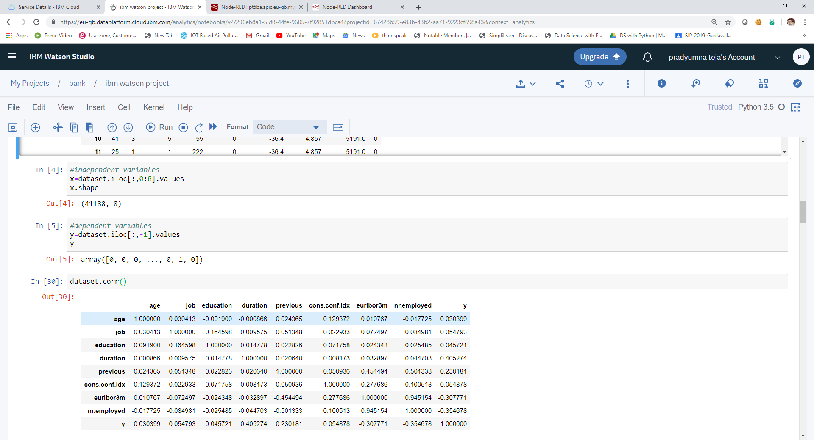

ROC_AOC Curve
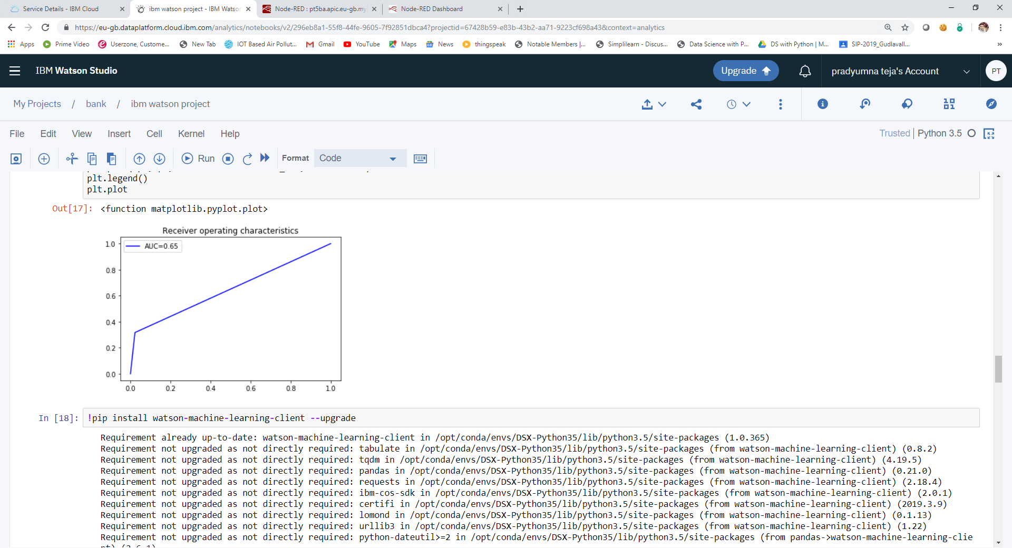

4.2 Statistical Techniques and data visualization
By importing matplotlib.pyplot library we have drawn graphs to demonstrate the AUC-ROC curves and by using bar graphs we have visualized the percentage levels of different techniques.
And we have used the co-relation function to demonstrate the impact of every factor on each other.
Correlation graph:
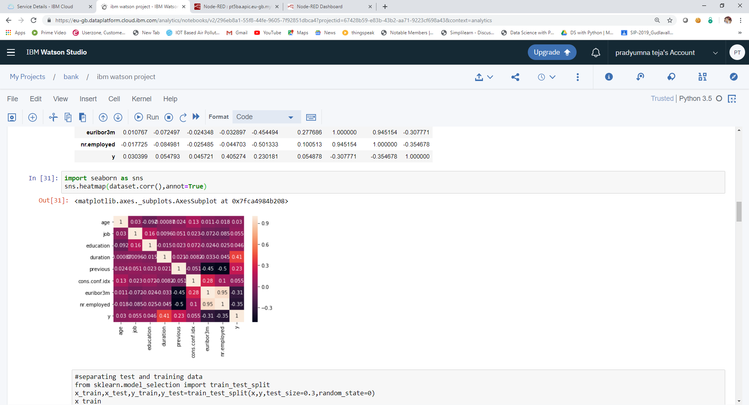
4.3 Data modeling using Supervised ML techniques
We consider logistic regression here. Because the accuracy we get is more compared to all the models. Logistic regression is a classification algorithm. It is used to predict a binary outcome (0/1, Yes/No, True/False) from the set of independent variables. It is a special case of linear regression where the outcome variable is categorical. The log of odds is the dependent variables, that is, it predicts the probability of occurrence of an event by fitting data to a logit function. Logistic regression is also termed as linear classification model.
In this example, a logistic regression is performed on a data set containing bank marketing information to predict whether a customer subscribed or not
- Prepare the data by creating dummy variables for each of the categorial columns (since we cannot use textual data to build our model).
- Divide the data into a training set and a test set.
- Run the logistic regression on the training data set based on the continuous variables in the original data set and the dummy variables that we created.
- Obtain the predicted probability that a customer has subscribed for a term deposit.
- Create a cumulative gains chart and calculate the area under the curve (AUC) for the test data.
- Obtain the model coefficients.
- Chart the logistic curve for both the training and test data
5. Findings and Suggestions
Prediction Form:

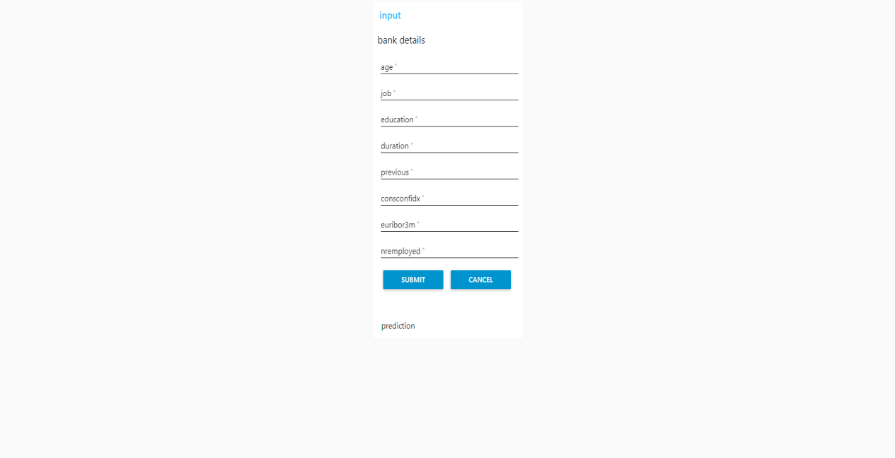

Prediction Values:
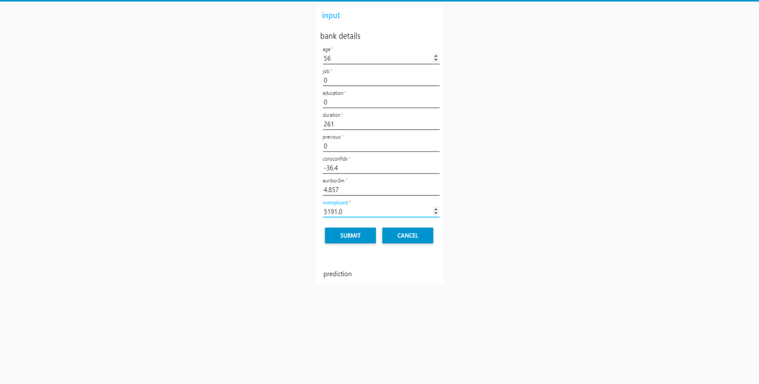

Prediction

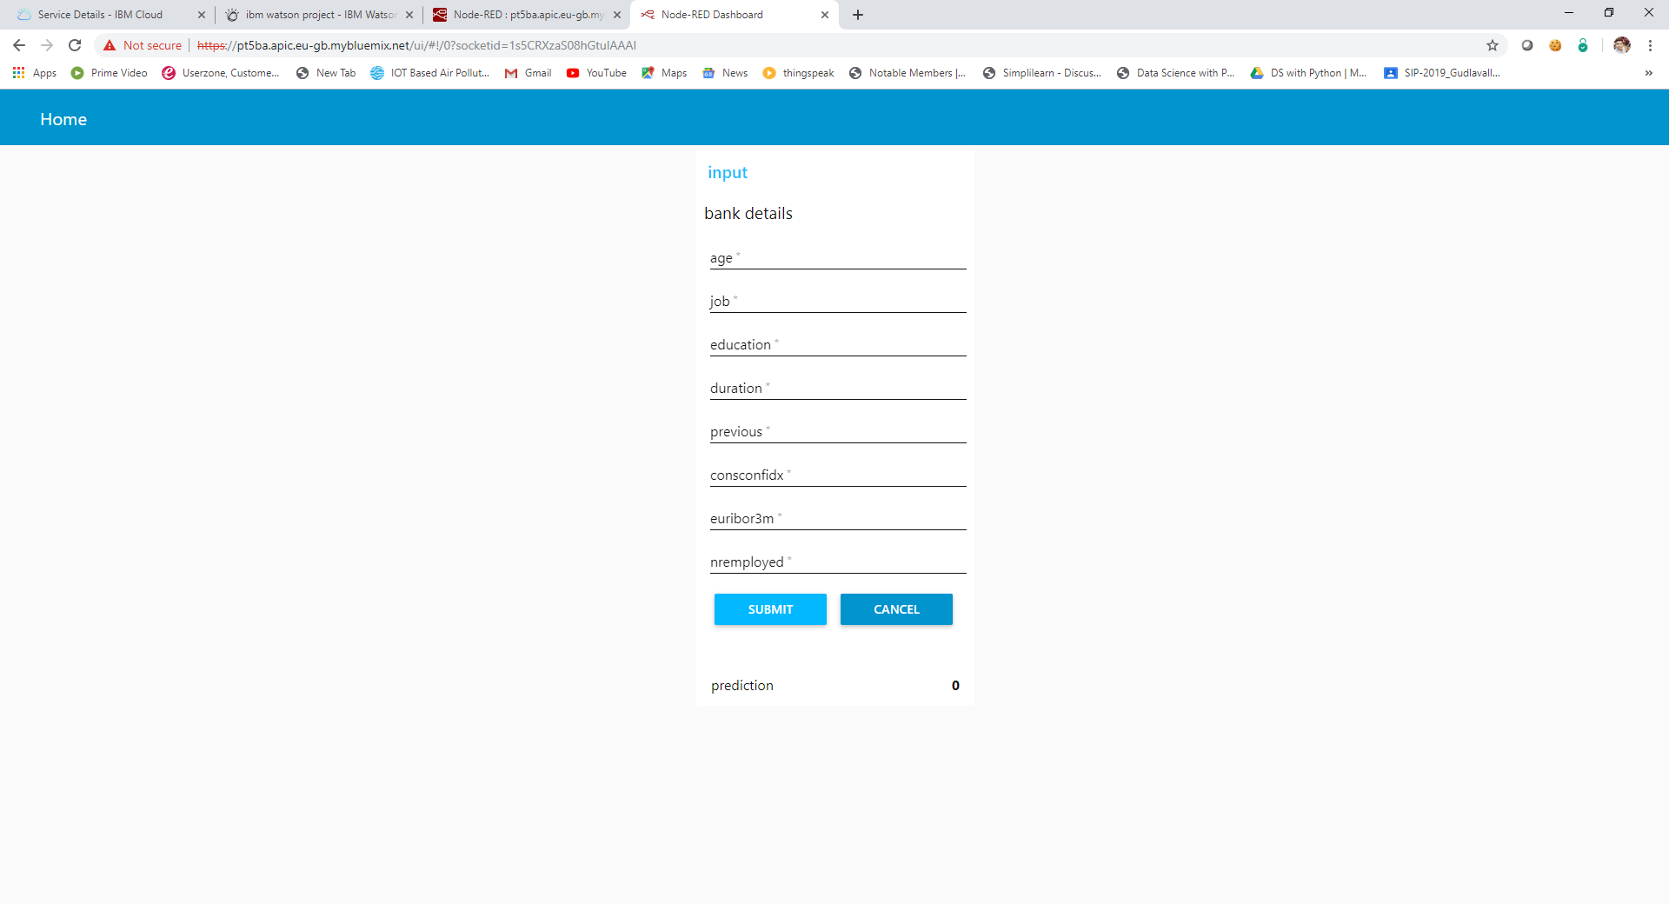

Prediction and Probability:

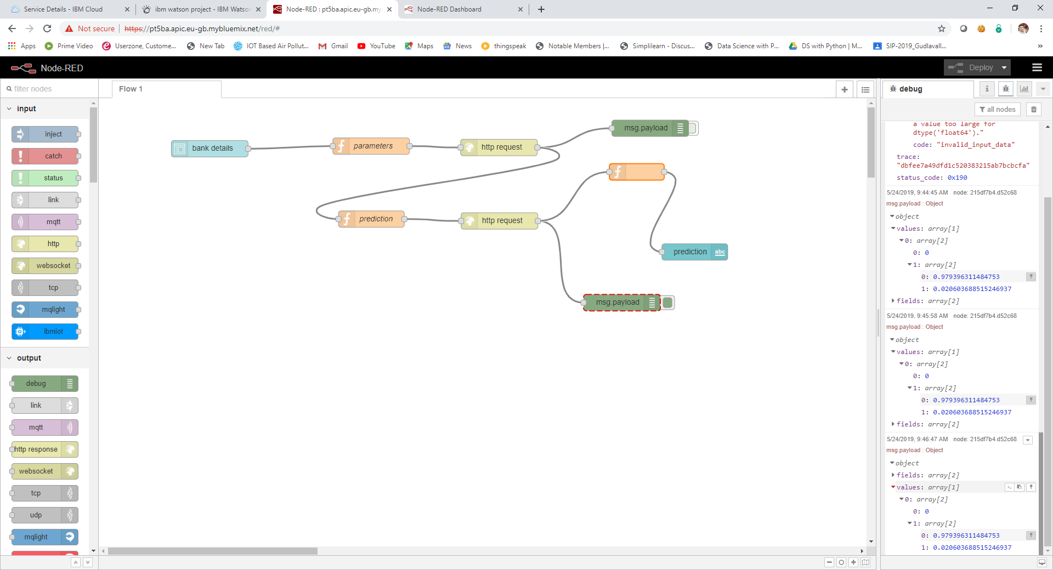
6. References
1. https://github.com/HegdeChaitra/Bank-Marketing-Campaign-Analysis
2. https://www.omicsonline.org/open-access/marketing-of-financial-and-banking-products-an-example-frombangladeshi-bank-2168-9601-1000159.php?aid=76106#11
3. https://www.nap.edu/read/1909/chapter/6#40
4. https://pt5ba.apic.eu-gb.mybluemix.net/red/#
5.https://pt5ba.apic.eu-gb.mybluemix.net/ui/#!/0?socketid=3fuCBpzGNjauxO64AABM
6. https://cloud.ibm.com/services/data-science-experience/crn:v1:bluemix:public:data-science-experience:eu-gb:a%2f6c38e4b66d4a4b9e950d0c859f00fc05:e8f3e29c-b36c-43fd-8b26-070c9613a358::

7. Conclusion
Our banks are following a definite traditional marketing plan and they are doing fine. Our Banks marketing approaches are quite nourishing for clients and it has affirmative effect on their revenue. But in nowadays, our banking sectors have to develop their marketing approach in order to sustain in this competitive world. If we improve our marketing plan of banking product, then bank will be able to gain more new client and that will have left a positive impact on client satisfaction, locality and revenue trend. Our banking sector will do better if we continue with our same marketing strategy, but also for sustainability we have maintain with the decades.

